TEMPLATE:

Project Description Document

Document Overview
(delete this section when finalizing creation of PDD)
This Project Description Document Template is a companion document to the General Protocol. As a tool to accomplish the Greenhouse Gas accounting requirements and lower the non-project costs for small-scale and local carbon offset projects, this template document aids in the preparation of project accounting towards compliance with Second Nature’s Carbon Commitment (formerly the American Colleges and Universities President’s Climate Commitment – ACUPCC). It is advised that this outline be filled in while building the documentation to fulfill project accounting, and used as a guidance tool.
Substantial components of project documentation will differ depending on the project type, whether an urban tree planting program, a farm soil management project, a methane capture & destruction project or any number of other projects. As mentioned in detail within the General Protocol, supplemental Project Type Specific protocols must be used in coordination with the General Protocol to complete this Template Document. Project Type Specific Protocols are being created within the growing Peer Review Network of Colleges and Universities who are creating channels for carbon offset projects to enrich curriculum and engage students. Project Type Specific Protocols located or created by a Peer-to-Peer institution are available for Colleges and Universities to use in pursuing similar projects if geographically relevant.
Please note that documentation requirements may necessitate additional space for data input and this outline must be scaled appropriately on a project by project basis. Also note that the examples presented will need to be adapted to each project type and section lengths may differ by project. Content and other elements may require different approaches then those presented through this template and example project, and it is therefore recommended to consult the Peer Review Network working group with specific questions while completing project documents.

(outline on next page)

Introduction
Project Title: [sample]
North Fields Afforestation Project
Purpose & Objective(s):
[Sample response:
The purpose of this project is to sequester atmospheric carbon dioxide (CO₂) through the afforestation of previously agricultural land presently managed as meadow. The Carbon Management Fund, an Oberlin College student run group, developed this project to serve as an active experiment, comparing a section of the project that has been planted with saplings against project areas that are being encouraged to self-recruit and naturally succeed to forest. Atmospheric levels of CO₂ reduced through this project will be estimated using growth models for trees, shrubs and other carbon sinks and applied to offset the carbon footprint of Oberlin College. Additionally, the project seeks to benefit the surrounding community through co-benefits of project implementation by increasing forested area with benefits including: water & air filtration, local & migratory wildlife & pollinator habitat, heat reduction, wind break and storm barriers. Furthermore, the project adds educational co-benefits for Oberlin College students who can engage and fulfill project research, monitoring and accounting. As one of the first projects of its kind, using the Second Nature Peer Review higher education offset network’s protocols and utilizing Peer Review to accomplish verification, this project seeks to pioneer this option for carbon offset project creation and provide an example for future efforts.]
Type of GHG Project:
[Sample response:
The North Fields Afforestation Project is an Afforestation Project which quantifies emissions based on forest stock monitoring. The project’s GHG impact will be calculated by applying peer-reviewed research to estimate the growth rates of planted and self-recruiting tree species.]
Site Details
Project Location:
[Sample response:
The North Fields Afforestation Project is located just beyond the city limits of Oberlin whose population is ~8,500, set in the agricultural landscape of Lorain County Ohio. The land is owned and managed by Oberlin College whose athletic fields are just east of the project site separated by a chain-link fence. Just south of the project site is a solar array that was constructed in the Fall of 2012 that is owned by Oberlin College but managed by the solar energy company and is fenced directly along the solar array’s perimeter. The afforestation project sites include the five areas demarcated in green in the image provided below and is a total of 8.86 acres. Running along the existing tree line of the project site in the image below is Oberlin College’s cross-country course track. Additionally, mulch pathways allow walkers and runners to pass through the areas around the Project Site and solar arrays. The area experiences a low amount of foot-traffic along the defined paths from college and high school cross country teams, joggers, walkers and student researchers who access the area through gates and pedestrian gaps in the eastern fence.]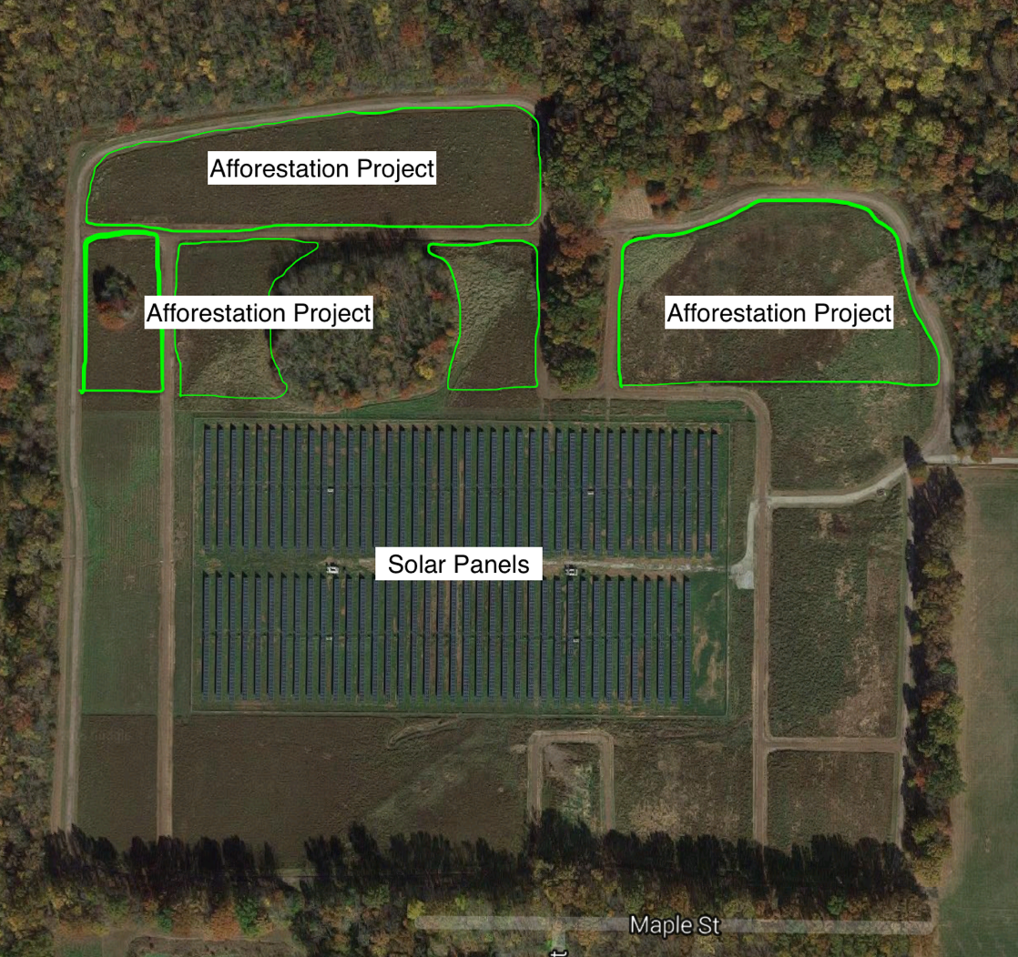
Condition Prior to Project Commencement:
[Sample response:
Oberlin College previously managed the project areas as meadow with limited intervention and simulating a burning cycle by mowing twice annually. Prior to this practice of management, the land was leased out to neighboring farmers and farmed in a conventional soy-corn rotation, with intensive fertilizer use. This change in practices occurred in 2012.]
GHG Impact
Description of Project Impact on GHG Emissions:
[Sample response:
Forest growth involves the removal of CO₂ from the atmosphere by building biomass in trees, roots, shrubs, soil, leaf litter, muff and deadwood. Project areas of new forest will grow, sequestering CO₂ in these measurable and quantifiable carbon sinks. Additionally, the elimination of the practice of simulated burning of these fields, which required mowing the fields twice a year will result in a reduction of GHG emissions from combusted fuel. The emissions reduced through management practice changes add to the project’s GHG Assertion and overall impact.]
Project Technologies, Products, and Services:
[Sample response:
The Project relies on saplings planted and self-recruited tree species to sequester carbon and promote native species forest growth. Growth models predict trees to store carbon over the project area at an increasing rate ranging from __ to __ mtCO₂e stored per year from project year 0 to project year 40.
The shrub layer is also expected to add substantially to the storage of atmospheric GHGs…
Lastly, the reduction of combusted vegetable oil fuel resulting from the elimination of the practice of simulated burning, by mowing twice annually, results in an annual reduction of ___ mtCO₂e.
The project excludes the harvest of forest products to eliminate potential sources of leakage and ensure all carbon generated by the project remains on-site. Ecosystem services will be provided by the project to benefit nearby communities.]
GHG Assertion (stated in mtCO₂e):
Identification of Risks to GHG Impact of Project:
[Sample response:
Project risks are assessed by applying the ACR Tool for Risk Analysis and Buffer Determination V1.0. This tool includes risk factors for afforestation projects including: financial risk, project management risk, social/policy risk, fire risk, disease and pests risk, and the risk of other natural disaster events. Using the guidelines from the ACR Tool for Risk Analysis and Buffer Determination, and applying local area-specific data for occurrence of wildfire, disease and pests, the largest risk factors are Financial, Project Management, and Disease and Pests each posing a 4% risk of project reversal. Social/policy risk, fire, and other natural disasters pose a 2% risk each. Therefore, the total risk factor = 18%, which will be accounted for proportionately through the buffer pool determination later in this document.]
Program Inclusion
[Sample response:
The North Fields Afforestation Project seeks eligibility within Second Nature’s Carbon Commitment, Peer Review Network. This Project Description Document and the Afforestation Protocol were each developed and approved by the Peer Review Network, using the good practice guidance provided by:
- Climate Action Reserve’s (CAR) Forest Project Protocol Version 3.3 for reforestation projects,
- Verified Carbon Standard (VCS) eligible Clean Development Mechanism (CDM) Methodology Protocol A/R Small-scale Methodology: Afforestation and reforestation project activities implemented on lands other than wetlands (AR-AMS0007),
- 2006 IPCC Guidelines for National Greenhouse Gas Inventories: Volume 4: Agriculture, Forestry and Other Land Use, and
- The American Carbon Registry’s Forest Carbon Project Standard.
Within the Peer Review Higher Education Network, protocols must meet the minimum requirements of marketable offsets as assessed and reviewed by the Technical Advisory Group. Satisfying the requirements of robust protocols will be reviewed by peer institutions with the capacity to assess carbon documentation completeness and accuracy, while performing project verification.]
Legal, Regulatory:
[Sample response:
The project is not the result of compliance with any federal state or local law, statute, rule regulation or ordinance. Carbon pools within the project site are governed by the legal contract signed by the project owner and operator ___, Oberlin College, which covers the 40-year crediting period of the project as well as the 40 years following the crediting period to ensure carbon remains stored in the project site.]
Technical:
[Sample response:
Oberlin College Grounds Manager, Dennis Greive has adopted the below components which comprise a management plan for the project site. To review the full forest management plan please consult Appendix __.
- Following the Forest Management Plan;
- Identifying any project reversals/issues that may arise
- Coordinating 5-year visits with the Ohio Division of Forestry to identify the overall health and treatment of invasive species. Mr. John Jolliff is the current State Forester.
- Maintain diversity of native species (>95% based on sum of standing carbon) or management plan to achieve this level of local
- Treat for invasive species by:
- Spot pesticide use — cull exotic/invasive plants (chop them at the base) try to get the plant and the seeds out of the area; and
- Selective culling to discourage Canada thistle and buckthorn.
- Maintain diversity of aged trees within forest (no more than 40% aged less than 20 years excluding significant disturbance) must be met within 25 years
- Encourage habitat for migratory birds through creation of gradual forest edges, ie. allowing shrubs and small trees to grow at the edge of the forest;
- Zero harvesting/sustainable harvest practices; and
- Increase standing live carbon (calculated by verification) except when a reduction occurs in line with risk reduction practices.]

Economic, Sectoral:
[Sample response:
No market factors pose a substantial impact to the project or the project site.]
Social:
[Sample response:
The project owner did not have previously stated goals or plans for the project site’s use or development as a forest. We are aware of no social or cultural elements that might negatively impact the project’s success.]
Geographic, Site Specific:
[Sample response:
The project site has not experienced commercial harvesting of timber within the last 10 years. The project is within the Peer Reviewed Offset Networks’ designation of local as it qualifies for each of the three definitions offered:
- Accessible by students from the College or University from which Afforestation Project funds originated without requiring greater than 1 day of travel roundtrip to visit the project site;
- Within the same State as the College or University;
- Within 100 miles of the College or University Campus.

Saplings selected for planting include: Sweet Gum (Liquidambar styraciflua), River Birch (Betula nigra), Red Maple (Acer rubrum), and White Oak (Quercus alba), each of which are native to the project site. Self-recruiting saplings will generally be native species, while the management plan details how non-native species will be identified and controlled.]

Temporal:
[Sample response:
The start date of the project is recorded as ___ which is the date that the project contract was signed. All calculations of project GHG impact shall select the date of this contract’s signature until the present, as the timeframe for measurement of forest growth and carbon accumulation.]
Roles & Responsibilities
Internal Structure:
[Sample response:
The North Fields Afforestation Project was paid for and executed by an arm of the Oberlin College, student led Green EDGE Fund: The Carbon Management Fund. This group receives oversight from the Comptroller and VP of Finance regarding financial decisions, as well as coordinating its activities closely with the Office of Environmental Sustainability. Green EDGE Fund decision are made by its voting student members and approved by either the Comptroller or the VP of Finance.]
Participant(s) contact info:
[Include contact info for relevant participants]
Project Stakeholders:
[Include contact info for project stakeholders]
Relevant regulators & administrators of GHG Program:
[Include contact info for regulators & administrations of the GHG Program]
Relevant Stakeholder Outcomes & On-going Communication:
[Sample response:
In this case, Oberlin College is the sole stakeholder of the project. The afforestation project will benefit Oberlin College by providing carbon-offset credits through the Carbon Commitment’s Peer Review Network towards achieving carbon neutrality as a campus. Oberlin College will also receive the co-benefits from increased forest area as a result of this project. The Project Operator, the Carbon Management Fund, will receive oversight from Oberlin College’s Office of Environmental Sustainability, and will have email and in person access to the Project Owner ____ and Project Maintainer Dennis Grieve. Communication will follow the project schedule to accomplish accounting, monitoring, verification and other tasks required to keep the project in line with the management plan.]
Environmental Impact Assessment:
[Sample response:
Not Applicable.]
Chronological Project Plan:
[Sample response:
Project Commencement Date: 2016

Project Termination Date: 2056

Frequency of Monitoring and Verification Reporting:
According to the Afforestation Protocol, annual monitoring of the project site will ensure management practices remain in use and identifying disturbance events. After an initial verification, which must occur within 2 years of the commencement date, subsequent verifications will occur at 5 year intervals. (sample chart below)]

Date | Task | Status
Spring, 2013 | Initial planting, simulated burning practice halted | Complete
Fall, 2013 | Measurement of adjacent forest to track growth | Complete
Spring, 2014 | Signs in place designating afforestation in progress | Complete
Fall, 2015 | 2nd study of adjacent forest confirms initial findings | Complete
Fall, 2016 | Project agreement signed and official commencement date | Complete
Fall, 2016 | Project accounting complete | Complete
Annual | Project monitoring, data input, and management system updating occur | On-going
2017; every 5th year thereafter | Initial Project Verification and subsequent verifications at 5-year intervals | On-going

Establishing Project Boundaries
[Below example is a complex project with many SSRs, some may be very simple.]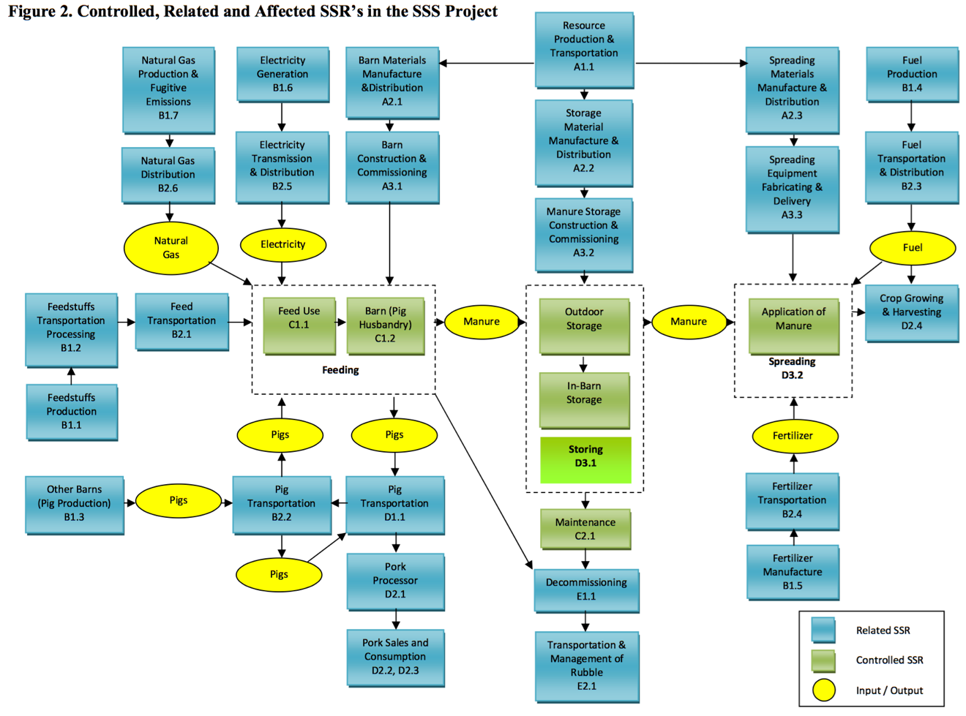
Project SSR List (from map):
Identified SSR | Controlled/ Related/Effected | Different from Baseline? | Rationale for Inclusion or Exclusion | Project Impact
[extend table as needed]
Determination of Baseline Scenario
Product or Service Granted by Project Activity:
[Sample response:
The project scenario provides land management, maintaining and increasing the property value of the project site, which is the critical requirement for the project site according to initial conversations with the Project Owners and Maintainers.]
Geographic Area and Temporal Range:
[Sample response:
The physical area is the area demarcated in the project aerial Figure 1. To determine the baseline scenario, the temporal range from 2013 when the sapling plantings occurred was evaluated projecting 20 years into the future based on interviews with Facilities and Grounds Managers. These interviews dictated that the area would be managed as meadow over this time period.]
Additional Criteria:
[Sample response:
The college’s cross-country course, which presently runs through the project site, was preferred to remain in its present location and not require re-routing.]
Baseline Candidates:
[Sample response:
- Managed Meadow (w/ Simulated Burning)
  - Existing practice of management on project site: area is managed through control of invasive species through spot control: mowed twice annually to simulate a meadow habitat.
  - The meadow scenario provides land management practices and increases property value by improving soil structure and nutrient levels.
- Athletic Fields for Oberlin College
  - Potentially, the athletic department of Oberlin College could decide additional athletic fields are needed. This would require initial leveling, regular mowing, and a large scale upfront investment.
  - The Athletic Fields scenario would ensure land management, requiring additional attention beyond the existing practice. This scenario would increase property value.
- Project Scenario: Afforestation
  - Through planted saplings and self-recruited trees, the project site will be allowed to grow into forested area. This will provide a living classroom for Oberlin College students and grant co-benefits to the surrounding area.
  - Land management would be maintained and verified by Peer Review network verifiers, additionally the land’s property value would increase, although carbon offset contract’s signed prevent changes to the carbon stock providing recourse to maintain the reduction of atmospheric greenhouse gasses should Oberlin College require to sell this land.]

- [Candidate Title]
  - [Candidate description]
  - [Functional equivalence]
- [Candidate Title]
  - [Candidate description]
  - [Functional equivalence]
- [Candidate Title]
  - [Candidate description]
  - [Functional equivalence]
- [Project Scenario]
  - [Candidate description]
  - [Functional equivalence]
- [Extend list as needed]
Barrier’s Test Results:
[Sample provided:
Barrier’s Test: N. Fields Afforestation | Economic | Social | Political | Overall Barriers Assessment (Small, Medium, Large)
Managed Meadow | None – Minimal maintenance | None – existing practice | None – existing practice | No Barriers
Athletic Fields | Large upfront expense | None – no shortage of fields | None – alumni donations boosted by athletics | Large – Multi-million dollar project to construct athletic fields
Project Scenario | Small – Upfront cost of saplings & site prep | None – no conflicts | Small – long-term land management contract for carbon pools | Small – Upfront cost and long-term contract pose project barriers

Barrier’s Test: [Project Title] | [Barrier #1] | [Barrier #2] | [Barrier #3] | Overall Barriers Assessment
[Baseline Candidate #1]
[Baseline Candidate #2]
[Baseline Candidate #3]
Project Scenario

Baseline Scenario Selection:
[Sample response:
Managed Meadow]
Project Scenario Additionality:
[Sample response:
The Project Scenario is additional beyond the Baseline Scenario by providing funding to unlock the project scenario through purchasing saplings, and providing the labor (paid and volunteer) to prepare the site for afforestation and mark it with appropriate signage. Additionally, the carbon offset program – the Carbon Management Fund – enabled this project to materialize building the structure to qualify this project towards Oberlin College’s carbon neutrality commitment. Further, additionality also resulted from the Carbon Management Fund’s efforts navigating the political landscape of Oberlin College’s Administration to secure a long-term contract that will protect the project sites’ carbon pools over the 40-year project crediting period and for 40 years beyond the project crediting period. The efforts and funding provided by project organizers and the Carbon Management Fund enabled the project to occur and therefore fulfill additionality.]
Baseline Scenario SSRs
Baseline Scenario SSR List:
Baseline Scenario SSRs | Controlled / Related / Effected
[extend as needed]
Unchanged Project-Baseline Scenario SSRs
Project: | Baseline:
[extend as needed]
Project Scenario Updated SSRs to Monitor or Estimate
Identified SSR | Different from Baseline? | GHG Impact (mtCO₂e) | Rationale for Inclusion or Exclusion* | Monitor or Estimate?
 | Yes |  | [__% excluded: de minimis constraint]
 | Yes |  | [__% included: substantial impact]
 | Yes
 | Yes
 | Yes
 | Yes
*Note: percentages equal portion of total project impact.
Baseline Scenario SSRs to Monitor or Estimate
[The baseline scenario SSRs must also be tracked to ensure your calculation of the project impact remains accurate and includes possible changes in the baseline emissions.]
Baseline Scenario SSRs | GHG Impact (mtCO2e) | Rationale for Inclusion or Exclusion | Monitor or Estimate?
 |  | [__% included: substantial impact]
 |  | [__% excluded: de minimis constraint]
Additional Clarification & Rationalization of SSR Selection
[Sample response:
The baseline scenario excludes soil organic carbon from calculation as it is an optional source of emissions for calculation within this protocol.]
Risk Assessment & Future Consideration
Project Permanence:
[Sample response:
Project permanence is a key consideration with afforestation projects as forests are prone to risks which threaten project reversal. Non-natural risks to project success include Financial Risk and Project Management risk which each hinge on the Project Owner’s financial solvency over the project’s lifespan (project crediting and post-crediting reversal monitoring) and the continuation of management practices over that timeframe as well. These are risks that face the majority of carbon offset projects, and especially afforestation projects due to their long timeframes. The risks of wildfire, disease, pests, and other natural disaster events (drought, tornadoes, storms, flood, earthquakes etc) also present considerable risk to project permanence despite efforts to reduce these factors through native species selection, and preventative management practices. Risks are evaluated by the ACR Tool for Risk Analysis and Buffer Determination and presented below:
Financial 4%
Project Management 4%
Social/Policy 2%
Fire (low risk area) 2%
Disease and Pests (no epidemic disease or infestation in area) 4%
Other natural disaster events 2%

TOTAL RISK FACTOR = 18%

To counter these risks, a conservative and generous buffer pool will be kept on reserve in case project reversal occurs in proportion with this Total Risk Factor.]
Additional Risks:
[Sample response:
The risk of leakage is small for this project. The largest risk of leakage comes from firewood gathering, but this practice is unlikely to impact the GHG assertion as the land is far from Oberlin College students, and is bordered on the North and West by college leased farmland. There are no communities reliant on the project area for forest products of any kind.]
Buffer Pool Designation & Total Project Risk Factor (as percentage):
[Sample response:
The project factors in 18% overall risk of project reversal or failure. The buffer pool designation is therefore 18% of annual reduction of atmospheric GHGs, which can be predicted based upon the projected impact of the project. Below is the projected contribution by project year:
This estimated buffer pool designation will be updated upon verifications and through monitoring events.]
Project Impact Calculation
Global Warming Potentials Used:
[Insert source of GWPs used and values]
Baseline Scenario Total Atmospheric GHG Impact:
[combine baseline SSRs]
Project Scenario Total Atmospheric GHG Impact:
[combine project SSRs]
GHG Assertion:
[(Project Scenario – Baseline Scenario) * (1 – Total Project Risk Factor) = GHG Assertion]
Calculation Procedure:
[Provide Sample Calculation]
[Reference appendix #_ for full list of calculations]
Manage Data Quality (Internal Review)
[Sample response:
This document was created by Tomorrow’s Climate Solutions LLC and reviewed internally by Oberlin Project Staff as well as externally by Duke University’s Duke Carbon Offset Initiative Staff providing an initial level of validation.]
Information Management System:
[Sample response:
The data for the basis of the project impact calculation is the product of peer-reviewed literature informed methodologies and very conservatively applied growth models. There is perhaps small amounts of uncertainty that exist within these initial calculations, but the project calculations have been performed conservatively such that subsequent verification of the project’s impact are expected to return greater than projected amounts of stored carbon. Measurement error is low and methodologies are conservative reducing the project data uncertainty.]
Project Monitoring Plan
Data for Collection:
Specific SSR | Monitored or Estimated? | Data Source | Collection Method | Responsible Party (for data collection)

Schedule of Calibration for Direct Monitoring:
[insert equipment calibration schedule, if applicable]
Conditions for Data Monitoring:
[Sample response:
Monitoring activities should be performed when the afforestation site has foliage existing on trees and shrubs for the purposes of accurately estimating crown cover percentages and stratification. This can typically be met by monitoring in the Spring, Summer or Fall.]
Data Collection & Monitoring Methods (include technical information needed to collect and monitor):
[Sample response:
Standard practices will be applied when taking DBH measurements, when identifying species, when estimating height and age, and when assessing crown cover in accordance with the CDM A/R Methodological Tool: Calculation of the number of sample plots for measurement within A/R CDM project activities V02.1.0 or following the guidance of other peer-review approved literature provided a rationale of the methodology applied is provided.
Annual walk-through surveyors must educate themselves prior to performing walk through duties, regarding project & prescribed forest management practices as well as to identify possible disturbance events (fire, pests, natural disaster, disease etc.).]
Project & Baseline Monitoring Schedule:
[Sample table]
Project Timeline | Monitoring Event Type | Data Collected
Start Date – once completed: | Stratification | Biomass stratification; if trees planted: species, DBH, height, estimated age, (GPS coordinates)
Years 1-4 | “Walk-through” survey | Ensure Natural Management Practice, Identify Disturbance Events
Year 5 | Full inventory | Representative sampling: Species, DBH, height, estimated age, (GPS coordinates)
Years 6-9 | “Walk-through” survey | Ensure Natural Management Practice, Identify Disturbance Events
Year 10 | Full inventory | Representative sampling: Species, DBH, height, estimated age, (GPS coordinates).
Years 11-14 | “Walk-through” survey | Ensure Natural Management Practice, Identify Disturbance Events
Year 15 | Full inventory | Representative sampling: Species, DBH, height, estimated age, (GPS coordinates)
Years 16-19 | “Walk-through” survey | Ensure Natural Management Practice, Identify Disturbance Events
Year 20 | Full inventory  Recalculation of baseline scenario | Representative sampling: Species, DBH, height, estimated age, (GPS coordinates). Pertinent laws, common practice and other information to determine baseline suitability.
Years 21-24 | “Walk-through” survey | Ensure Natural Management Practice, Identify Disturbance Events
Year 25 | Full inventory | Representative sampling: Species, DBH, height, estimated age, (GPS coordinates)
Years 26-29 | “Walk-through” survey | Ensure Natural Management Practice, Identify Disturbance Events
Year 30 | Full inventory | Representative sampling: Species, DBH, height, estimated age, (GPS coordinates).
Years 31-34 | “Walk-through” survey | Ensure Natural Management Practice, Identify Disturbance Events
Year 35 | Full inventory | Representative sampling: Species, DBH, height, estimated age, (GPS coordinates)
Years 36-39 | “Walk-through” survey | Ensure Natural Management Practice, Identify Disturbance Events
Year 40 | Full inventory | Representative sampling: Species, DBH, height, estimated age, (GPS coordinates).

Project Timeline | Monitoring Event Type | Data Collected
[Extend table as needed]
Project Verification
[Sample response:
Verification will be carried out through the Peer Reviewed Network by a peer-institution with an experienced but non-accredited verifier. According to the Afforestation Protocol, this selection for verification type adds 5% to overall project uncertainty, which has been added into the calculation of the GHG Assertion. It should also be noted that the guidelines for verification are still in development for inclusion within the Carbon Commitment. The program is presently in its trial phase while all necessary accounting components are structured to provide robust and reliable carbon offsets. This Project Description Document therefore documents the existence of this project, but must await further development within the Carbon Commitment guidance and structures before being counted to offset emissions for Oberlin College.]
Document Author(s) & Contact
The author(s) of this document, [insert your name(s)], attest that they have performed duties regarding the accounting documentation required within this document with complete honesty and truthfulness. The signature below certifies that the authors did not intentionally misrepresent or present information in misleading ways through this document.
Author Signature:_____________________________________________
The author(s) welcomes your comments and invites you to be in communication. Please contact them at [insert contact info].

Climate Action Reserve, 2012. Forest Project Protocol Version 3.3. www.climateactionreserve.org/. http://www.climateactionreserve.org/how/protocols/forest/dev/version-3-3/
Clean Development Mechanism, 2013. AR-AMS0007: Afforestation and reforestation project activities on lands other than wetlands --- Version 3.1. Cdm.unfccc.int/. https://cdm.unfccc.int/methodologies/DB/J6ZHLX1C3AEMSZ52PWIII6D2AOJZUB
IPCC, 2006. Guidelines for National Greenhouse Gas Inventories: Volume 4: Agriculture, Forestry and Other Land Use. International Panel on Climate Change. http://www.ipcc-nggip.iges.or.jp/public/2006gl/pdf/4_Volume4/V4_04_Ch4_Forest_Land.pdf
The American Carbon Registry, 2009. Forest Carbon Project Standard Version 1. www.responsiblepurchasing.org/. http://www.responsiblepurchasing.org/purchasing_guides/carbon_offsets/standards/American_Carbon_Registry_Forest_Carbon_Project_Standard.pdf
Figure courtesy of GHGMI Case Study: The Summerland Swine Syndicate, 2009. Course 202: Basics of Project Level GHG Accounting. www.ghgmi.org/courses
According to the ODNR Division of Forestry’s State of Ohio Wildfire Hazard Assessment, Afforestation Project Sites eligible within this protocol are all within Ohio’s low risk wildfire regions: 1 & 2. Page 160 provides a raster based map outlining the risk of wildfire on a township by township scale.

